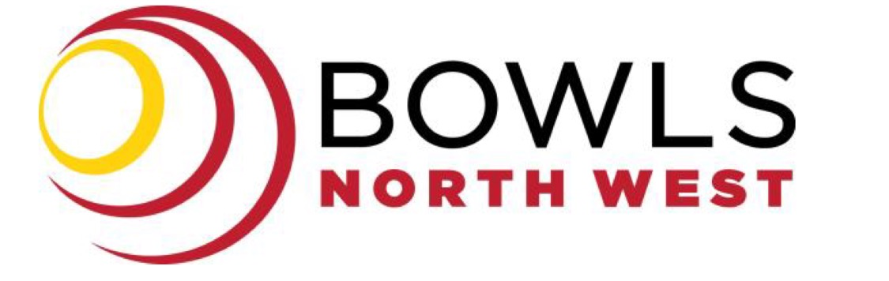

BNW BOARD MEETING MINUTES

Date: Monday 22nd May 2023

Venue: PENGUIN BOWLS CLUB

Time: 5.30 pm

1. MEETING PROCEDURES AND ATTENDANCE
1.1. ATTENDING
Ben Fidler President
Julie Schmidt Vice-President/Director
David Jeffrey Vice-President/Director
Barry Magnus Director
Geoff Williams Director
Mark Atkinson Director
Ali Venn Director
Tracey Little CEO
- APOLOGIES
3. ADOPTION OF MINUTES
Recommendation: That the minutes be accepted as presented:
Board Meeting – Monday 17th April 2023 Moved: Dave Jeffrey Seconded: Mark Atkinson
Carried: Yes
4. BUSINESS ARISING FROM MINUTES
- BNW Strategic Plan - Meeting TBA after AGM

- Grant & Live Stream – Update – List of Equipment to be sent to all Board Members. Insurance has been approved. Next Live Stream will be at Port Sorell.

- Expressions of Interest – Coach – Chris Dudman, Barry Magnus and Colin Willcox – endorsed by the Board. Advertisement to be made. Selectors – Open Men – Ricki Richardson, Open Ladies – Karen Redman, Over 60s Ladies – Sandra Jackson, Over 60s Men – to be filled, Junior – Rick & Pam Sutton. Team Managers – Senior Men’s – Jason Morrisby, Open Men’s – to be filled, Ladies Open and Over 60s – to be filled. Junior – Danny Patmore with assistance Jill Stokes.

- Match Committee – Expressions – Darren Fielding, Greg Douce, Mick Filluel, Gloria Campagne and Peter Thow. Send Letter to Match Committee thanking them for their expressions. Board endorsed – Darren, Greg, Mick and Gloria to fill the roles.

- BNW Coaches Proposal – read. Motion: Mark Atkinson, Seconded: Ali Venn Carried: Yes
5. CORRESPONDENCE:
- BTAS Board Member from NW – email BTAS to have more time to find an appropriate person to fill the role.

- RCC Agenda & Report - tabled

- BTAS Prize Money email - tabled

- BNW SWC Centralization Letter - tabled

- Letter of Railton Carnivals dates – to be sent to Match Committee

- Email from Noelene Purton – P&A – tabled – response made to Noelene.

- BTAS Insurance and what it covers - tabled

- AGM Flyer and Nomination Forms – sent to all clubs

- Ulverstone New Uniform design – tabled and approved

- BTAS email – Juniors – Nationals - tabled

- BTAS Annual Report – tabled

Recommendation: THAT the correspondence be received.
Moved: Mark Atkinson Seconded: Barry Magnus Carried: Yes
6. FINANCE/CEO:
Summary of Financial Position – Read
- Bank Statement – Read.T
- Budget – final approved and in Xero.
- BTAS Capitation invoices sent to all clubs, BNW fees and levies will follow later.
- Audit – completed – tabled
- Insurance for Live Stream – tabled.
- Long Term Deposit – funds to be put into a Term Deposit - $40,000.00 Motion: Ben Fidler Seconded: Geoff Williams Carried: Yes
Recommendation: THAT the comments/discussion re CEO/ Financial Report is noted.
THAT the Financial statement be received, and the accounts ratified as presented.
Moved: Tracey Little Seconded: Dave Jeffrey Carried: Yes
7. GENERAL BUSINESS –

- Barry Magnus – Travel and Play – Barry to look into Bowls Trips with a Travel Company.

- Ben Fidler – tabled RCC information – some key points –
- Synthetic Greens – voted in favour – majority.
- COP – Bowling Arms Markers – players need to understand the COP if they enter.
- Co-contributions – BTAS State Players will need to contribute within 3 years.
- Calendar of Events – draft changes to come out.
- Uniform Policy – BTAS is going to BA about this.
- WWVPC – BTAS sent to all Clubs.
- SWC – To be confirmed if changed.
- Social Media Policy – is in place.
- Weather Policy – BTAS to look into this for indoor centres, etc.
- BTAS roster program – ask for this to be sent to BNW.

- Promotion & Relegation – 9 Team Roster for Saturday. Thursday – email to be sent and added to Executive Meeting – options – 1. 6,8,8,6 Divisions, 2. 7,7,7,7 Divisions or leave as is and remove Div 4.

- Barry Magnus – Junior Report – tabled.

- Julie Schmidt – Club Report – tabled. CEO to answer questions from Latrobe.

- Dave Jeffrey – Match Committee Report – tabled.

- Executive Meeting – Monday 17th June 2023 – 5.30pm (just before AGM).

- Umpires from Clubs – Email to all clubs – they have till Friday 26th May to respond, if no response this will be opened up for any member to express their interest.

8. NEXT MEETING
Confirmation of next Board Meeting - AGM – Monday 19th June 2023, 7pm Ulverstone Bowls Club.
Meeting Closed: 7.12pm
Signed by:

Tracey Little CEO Bowls North West Inc

